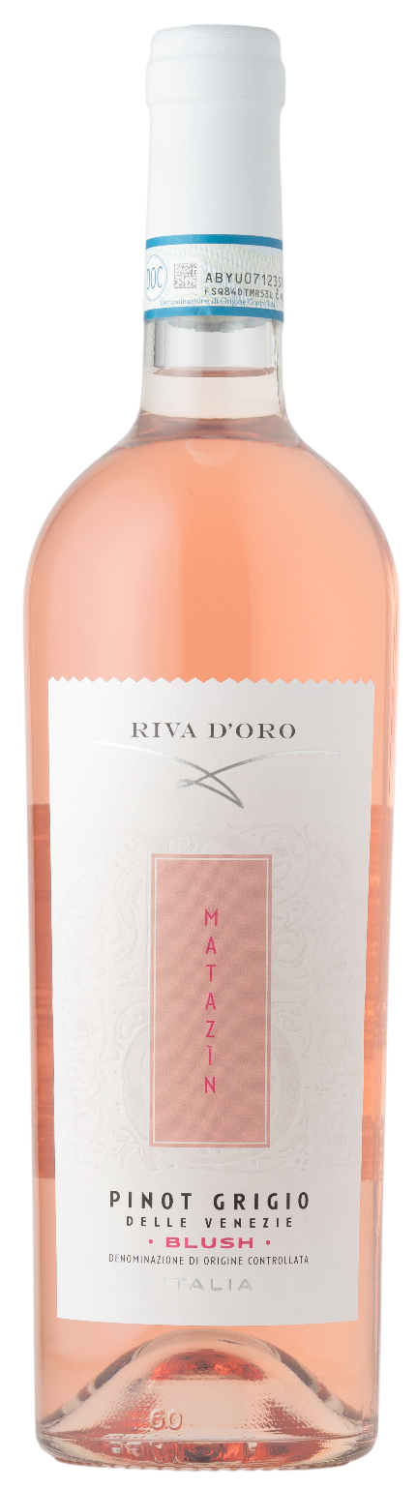
PINOT GRIGIO BLUSH DOC – MATAZIN

Grape: Pinot Grigio 100%
Alc. Vol.%: 12
Vintage: 2025
Residual sugar g/l: 5,0
Total acidity g/l: 5,6
Region: Veneto
Production zone: Vineyards in the Venezie area
Capacity: 750ml

CHARACTERISTICS

Vinification: After milling the grapes, the juice and the peels are mashed in refrigerated tanks. The deep red peels are conserved only for few hours in the must, so a light colour extraction is guaranteed
Aging: In steel tanks until bottling
Yield per ha: 18000kg
Colour: Light rosé
Bouquet: Notes of tropical fruit
Flavour: Harmonious, with a fresh and lively finish

SERVING SUGGESTIONS

Best enjoyed with fish, rice and pasta courses; or as an aperitif.
Serving temperature 6-8 °C
TECHNICAL INFORMATION / PALLETIZING

Size 750ml:
Article Nr. V09013A
GTIN-13 bottle 8017868001959
GTIN-13 carton 8017868003274
Closure Cork
Bottles / carton 6 bottles
Pallet size 80x120cm
Cartons/layer 21
Cartons/pallet 105
Kg/carton 7,8
Kg/pallet 840

Contains sulphites
GMO Free
Revisione 01. 14.05.2026

